2.1.4 Medical Director – MyMedicare Registration and flagging
MyMedicare Registration Form via Letter writer
Letter writer (RTF format) will auto-populate with patient details
ready for patient to provide sign consent.
Patient File → Tools → Letter Writer (F8) or  → File → New → Ok

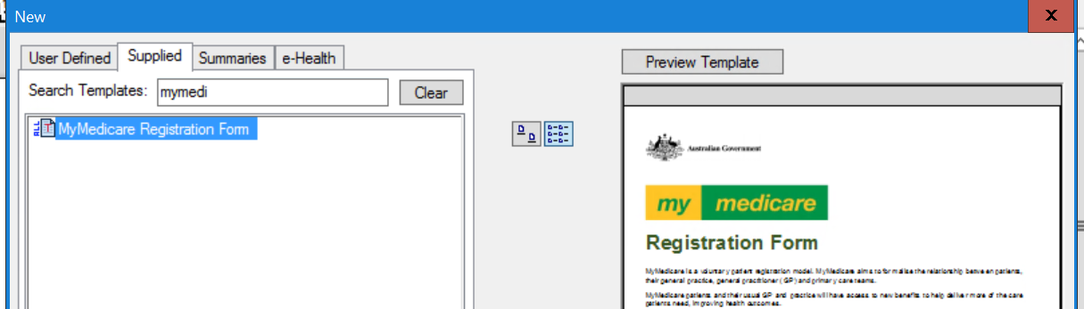

Individual Patient Registration
File → Open Patient → View details →tick “This patient is registered with this Practice for MyMedicare” → select Preferred GP = “Regular Practitioner” → Save
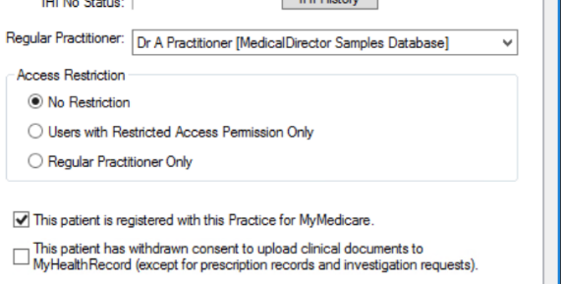

Bulk import option of MyMedicare:
Download exported registration list from HPOS for patient registration status and import list using MyMedicare Import Wizard or full details include HPOS screenshots – refer to WentWest’s Medical Director Guide for MyMedicare

