Adding Frail screen to AUTOFILL FOR 75+ HEALTH ASSESSMENT in Best Practice
May 2026 V6

The 75+ health assessment can be improved by:
- Adding a FRAIL screening tool
- Asking about exercise tolerance using the following questions:
  - Do you have difficulty lifting or carrying items (eg bag of shopping)?
  - Are you walking more slowly than a few years ago?
  - Do you have difficulty getting out of a bed or off a chair?
  - Do you have difficulty climbing steps?
  - How many trips or falls have you had in the past 12 months?
  - Are you easily exhausted or tired with activity?
  - How is your balance or steadiness now compared to a few years ago?
- Performing objective assessments of muscle strength such as 4m walking test, grip strength measure with a dynamometer and leg strength test with timed 5 sit-to-stand
- Assessment for risk of malnutrition using the mini Nutritional Assessment (MNA) https://www.mna-elderly.com/sites/default/files/2021-10/mna-mini-english.pdf
- Reviewing AIR and check for shingles, COVID, influenza, RSV, Boosterix (whooping cough+ tetanus + diphtheria) and pneumococcal vaccinations
- Adding a Kidney Health check (renal function, BP check and urine ACR) (40% of people aged 75+ will have evidence of Chronic Kidney Disease)…date last done and date due
- Adding an osteoporosis screening check. Osteoporosis risk can be assessed using the FRAX calculator. https://www.fraxplus.org
  - Check if there has been any minimal trauma fracture in past? Y/N. When was last Bone Mineral Density (BMD) date…..next due (5 year intervals if no evidence of osteoporosis on previous BMD, and 2 yearly if has established osteoporosis/had minimal trauma fracture/high risk)
- Checking blood pressure laying and standing to assess for postural hypotension
The steps to do this are the create a short cut or “AUTOFILL” know as /FRAIL

The steps are:
- Find the Autofill button at bottom of the usual consult entry screen

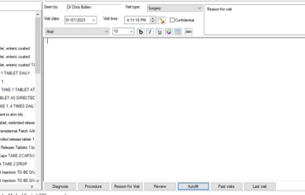
- Click on the “Add” button to add a new autofill

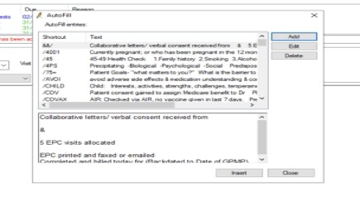

- Then add the required text (see below):
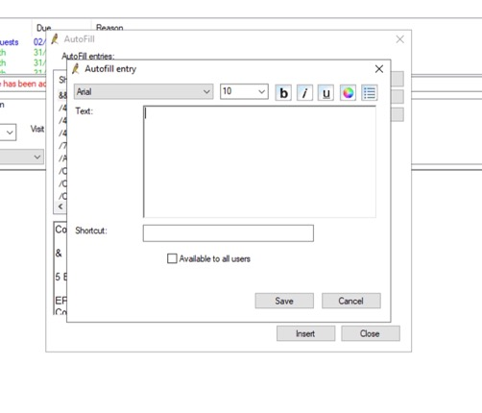
Use the following text to be inserted – “copy and paste” ALL the text in the next section below on pages 3 and 4:

Ask "What matters": List a person's goals, what’s on their "bucket list” to do?
What is stopping you from doing them?
How often do you feel lonely or isolated?

Social History: Update at each visit, and document:
Partner status/ living alone, pet names, hobbies, carer name and details,
Had MyAgedCare assessment: yes/no
Care package: name of provider and contact details
Other support organisations: Community nurse, Meals on Wheels, Local council
Continence aids: pads, catheter
Legal documents: Advanced Directive, Power of Attorney
Language issues: requires an interpreter or has speech issues

MyMedicare registration: yes/no

FRAIL screen: (Professor John Morley)

F – Over the past 4 weeks, have you felt Fatigued or tired most of the time? yes- 1 point
R - Resistance- Do you have difficulty walking up a flight of stairs? yes- 1 point
A - Ambulation- Do you have difficulty walking around the block (400M)? yes- 1 point
I – Illness- Do you have 5+ long-term/chronic conditions? yes- 1 point
L - Loss of weight -Have you lost (unintentionally) 5% body weight in the past 12 months? yes- 1 point

Frailty Score - /5
If scores 3+, then the person is living with frailty
If scores 1-2, the person is prefrail
Both groups will benefit from:
- Resistance type exercises (home or supervised at least 2 x week to build muscle)
- Increase protein in diet (aim for 1.5g per KG ideal bodyweight per day and divide over the day for 25-30g of protein per meal)
- Medication review: what can be deprescribed to improve fatigue and mobility?
- Daily Vitamin D to improve muscle strength

Exercise Assessment:
Mobility discussion: Start with asking “how steady are you feeling" rather than how many falls have you had?

Then, ask about exercise tolerance using the following questions:
  - Do you have difficulty lifting or carrying items (e.g., a bag of shopping)?
  - Are you walking more slowly than you did a few years ago?
  - Do you have difficulty getting out of bed or off a chair?
  - Do you have difficulty climbing steps?
  - How many trips or falls have you had in the past 12 months?
  - Are you easily exhausted or tired with activity?
  - How is your balance or steadiness now compared to a few years ago?

The “Muscle Health Check” (Sarcopenia risk assessment):
(Use the age-related values sheets provided for each muscle check to assess)
- Grip Strength Test- When sitting, use a dynamometer- do twice to give the best grip strength on both hands- check the normal values sheet- and mark “Strong”, “Normal” or “Weak” for age.

- Mobility Test: the 4 Metre walk test- aim to do in less than 5 seconds
0.6m/sec or less - Seriously Abnormal
0.6m/sec - 1.0m/sec - Abnormal
1.0m/sec - 1.4m/sec - Normal
1.4m/sec or more - Superior
- Sit to stand test- using a stopwatch on a phone, measure the time to perform 5 sit-to-stands?
(NOTE: if > 11 seconds, muscle strength is reduced, if >17 seconds-> increased risk of hip fracture and hospitalisation)
With any person found to be below expected times/strength, please recommend a resistance exercise program to build strength.
Osteoporosis screening check.
- Use FRAX risk assessment https://www.fraxplus.org
- Any minimal trauma fracture in past (“a fall from standing height”)? Yes/No
- Last Bone Mineral Density (BMD) date………
- BMD next due (5-year intervals if no evidence of osteoporosis on previous BMD, and 2-yearly if has established osteoporosis/had minimal trauma fracture/high-risk groups).. ……..(add BMD reminder)

Nutrition assessment: Use a Malnutrition risk assessment:
Check MiniNutritional assessment https://www.mna-elderly.com/sites/default/files/2021-10/mna-mini-english.pdf

Immunisations
Please view AIR (best to do this before health assessment template is opened )
Check if Immunisations up to date and document when immunisations are next due:
- Pertussis, diphtheria, tetanus (all in Boosterix): Yes/No
- Pneumococcal (Prevenar 13): Yes/No
- Shingles vaccine (Shingrix) Yes/No
- Influenza Yes/No
- RSV Yes/No
- COVID vaccination status : Last performed: Next Due:

Kidney Health check:
- When did the person have a Kidney Health Check (renal function, BP check and urine ACR)
(40% of people aged 75+ will have evidence of Chronic Kidney Disease with eGFR < 60mls/min)
- Date last done………. and date due………. (add annual reminder)

Medicines:
- Ask and document if medications are in a webster pack or other medication dose aid
- Check for any over the counter medications and vitamins and supplements
- Document usual pharmacy name, phone and email
- Ask if there are any medications the person struggles to swallow or remember
- Offer a Home Medication Review

Postural BP check: Take blood pressure laying and then standing to assess for postural hypotension, which is a common side effect of medications in older people

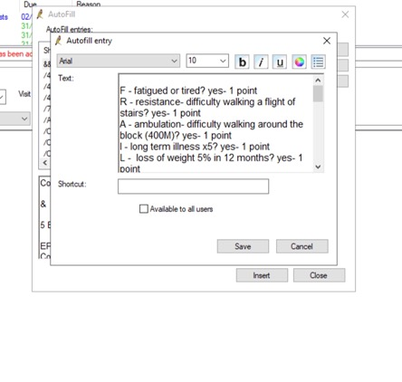

- Add a “shortcut” name such as /Frail or #Frail avoid using the word without a forward slash or hashtag as the autotext will all appear anytime a person types Frail in the notes!! And tick the “available to all users” box so all the practice can use.

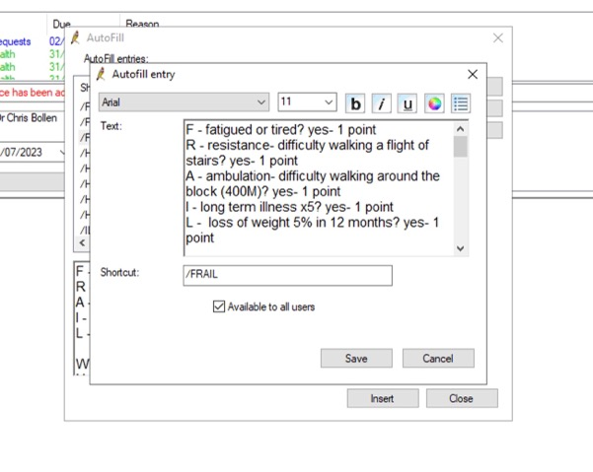
- How to use the autotext if you wish to use it during a health assessment? Option 1 is to simply type /frail or #frail in the health assessment “History and Examination” box. This will ensure the FRAIL screen and other information will also appear in the printed version of the health assessment.

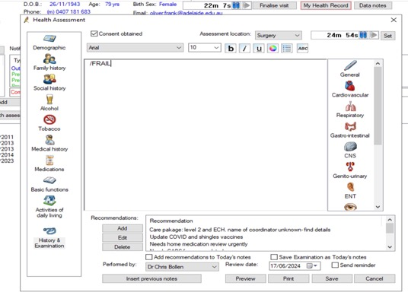

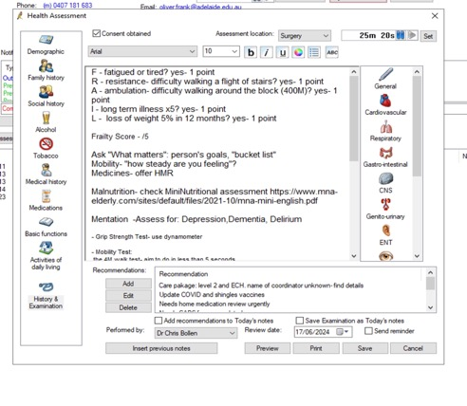

- Option 2 is to click on the Autotext button at bottom of consult notes. And find the /frail short cut….click on the “Insert” button, and it will all appear in the consult notes. However this method will not document the FRAIL screen and other information in the printed version of the health assessment.

